Article 1: GENERAL INFORMATION
Club name:
Club mandate/mission: This section outlines why the club exists. This is where the mandate of the club is introduced, detailing what purpose the club shall serve.
Meetings: This section outlines how often the club will meet and for how long.
Email address:
Website:

Article 2: EXECUTIVE OFFICERS AND SIGNING AUTHORITY
Club Executives must all be current UBC Faculty of Dentistry students.
Please consider including information on:
Office and Duties
The below outlined positions are only an example of what constitutes an Executive for most clubs. You are free to decide what positions you need, what names they will take and what duties each will be responsible for. Duties that are recommended to be included are:
a. Each Executive member is required to attend all meetings of the Club
b. The Executive shall adhere to the [insert Club name] constitution and utilize it for reference of operational decisions
c. The Executive and their respective duties of [insert Club name] shall consist of: [List position and duties]
Executive Terms of Office
This section describes how long someone in an Executive position shall hold office.
- Example: The term of office for all Executive positions shall comment September 1st and end on April 30th of the following school year

Executive Elections
This entire section is required to ensure fair election for all candidates and to ensure that all members of the club are made aware of an upcoming election if election processes are in place for a Club.

Transition
This section explains how the Club will demonstrate the likelihood of future membership. Specifically, how an incoming club Executive will be informed of their duties by the outgoing Executive. Most successful clubs implement some form of Executive transition program.

CLUB MEMBER ROSTER
This section describes who can be a member of the club.
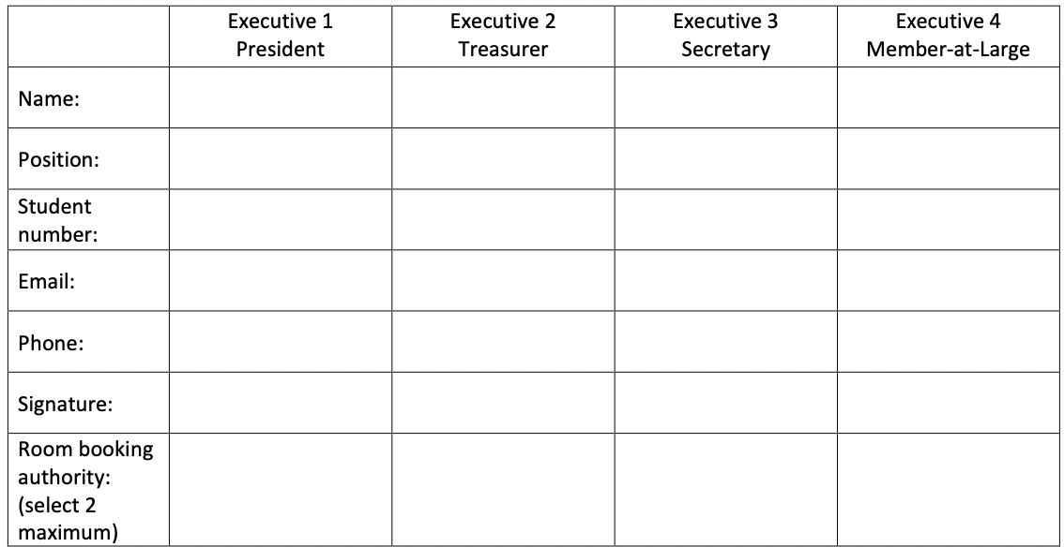

NOTE: All fields, except phone number, are mandatory and must be completed by all members in order for them to be validated club members. 2/3 of club members must be current UBC Faculty of Dentistry Students.
- Example: This club is open to any student of UBC’s Faculty of Dentistry. A valid membership shall be recognized for the term September to April. At all times [insert club name] will have a minimum of 5 members.

Article 4: Amendments
This section details how changes to the Club’s Constitution are made.
- Example: This Constitution shall comprise the operating basis of the [insert Club name]. All amendments to this document must be ratified by a two-thirds vote of the Club membership. A copy of the amended Constitution must be submitted to FOD Student Services within one week of ratification.

Article 5: Annual Plan
EVENTS AND ACTIVITIES OUTLINE
Meetings:
Occurrence: Weekly / Bi-Weekly / Monthly
Day: Monday / Tuesday / Wednesday / Thursday / Friday
Time: ______________ AM / PM

PREACTICES, EVENTS AND FUNDRAISING IDEAS:
Note: Where are you planning to practice? Is it on campus or off campus? Does this cost money? These are only ideas, accommodations will be made where applicable, space depending.
On campus:
______________________________________________________________________________
______________________________________________________________________________
______________________________________________________________________________
______________________________________________________________________________
______________________________________________________________________________
______________________________________________________________________________
Off campus:
______________________________________________________________________________
______________________________________________________________________________
______________________________________________________________________________
______________________________________________________________________________
______________________________________________________________________________
______________________________________________________________________________

BUDGET PROPOSAL
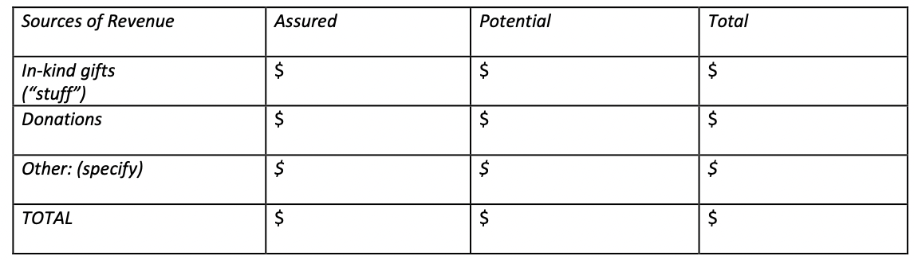
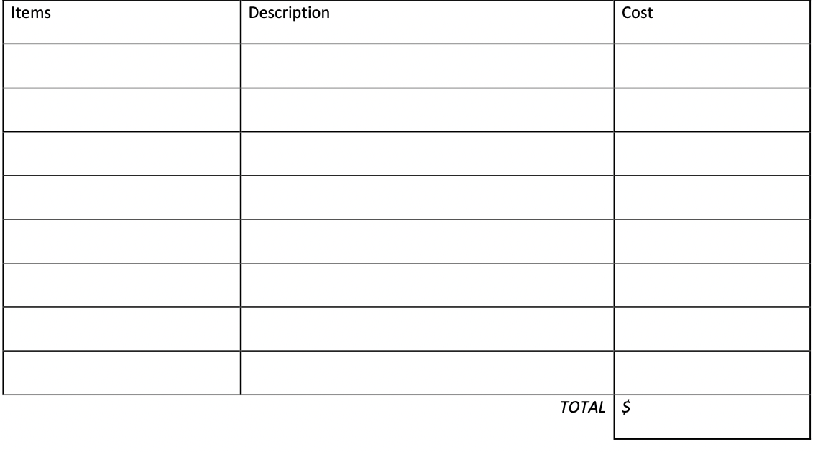
EXPENDITURE:
Revenue:

